Ex 1 : Comparative study of low-code development versus traditional application development
approaches.

1. Aim:

To study and compare the traditional application development approach with the low-code development approach based on development process, coding effort, development time, cost, maintenance, and overall productivity.

2. Introduction to the Traditional Approach

Traditional application development is the conventional method of building software using programming languages such as Java, Python, C#, or JavaScript. Developers write the application's source code manually and perform activities such as designing, coding, testing, debugging, deployment, and maintenance.
Features:
- Requires strong programming knowledge.
- Development takes more time.
- High flexibility and customization.
- Suitable for large and complex applications.
- Requires separate teams for design, development, and testing.
Advantages:
- Highly customizable.
- Better performance optimization.
- Greater control over application architecture.
Disadvantages:
- Longer development cycle.
- Higher development cost.
- Requires experienced developers.

3. Introduction to the Low-Code Approach
Low-code development is a modern software development approach that uses visual interfaces, drag-and-drop components, and minimal hand coding to build applications quickly.

Features:
- Visual development environment.
- Drag-and-drop UI components.
- Reusable templates and workflows.
- Faster application development.
- Easy integration with cloud services and databases.
Advantages:
- Rapid application development.
- Reduced coding effort.
- Lower development cost.
- Easy maintenance.
- Enables citizen developers to build applications.
Disadvantages:
- Limited customization.
- Platform dependency.
- Less suitable for highly complex applications.

4. Diagram Showing the Stages of Traditional and Low-Code Development

Diagram Low-Code Development

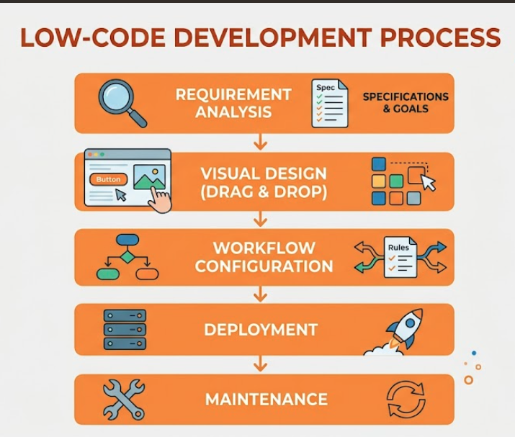

Diagram Traditional Development

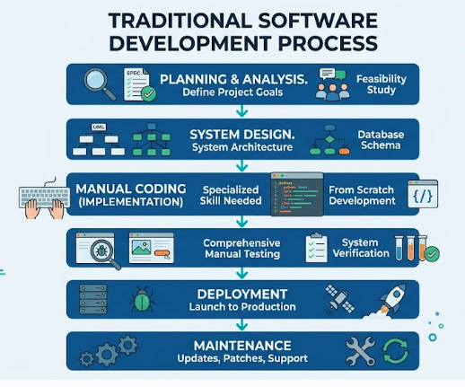

5. Comparison Between Traditional and Low-Code Development

Feature | Traditional Development | Low-Code Development
Coding | Manual coding required | Minimal coding
Development Speed | Slow | Fast
Cost | High | Lower
Programming Skills | Required | Basic knowledge is sufficient
Development Time | Weeks or Months | Days or Weeks
Customization | Very High | Moderate
Maintenance | More difficult | Easier
Productivity | Moderate | High
Best Suited For | Complex enterprise applications | Business applications, prototypes, internal tools
Time to Market | Longer | Shorter

Conclusion
Traditional application development provides maximum flexibility and control but requires significant time, cost, and programming expertise. In contrast, low-code development accelerates application creation through visual tools and minimal coding, making it ideal for rapid development and business applications. The choice between the two approaches depends on project complexity, budget, development timeline, and customization requirements.

